Program Management Plan
  - Enhance Your Program Management with PMI Standard Templates
Welcome to the Program Management Templates designed according to PMI's Standard for Program Management - Fifth Edition (2024). These templates are invaluable tools for professionals preparing for PgMP Certification on Knowledge Map (https://knowledgemap.pm). By completing these templates for your real programs, you seamlessly blend real-world experience with PMI program management concepts, ensuring a comprehensive understanding and practical application.
Explore the full range of templates to streamline your program management processes and elevate your expertise. Available Templates:

- Program Business Case
- Program Charter
- Program Management Plan
- Program Risk Register
- Program Benefits Register
- Benefits Management Plan
- Stakeholder Register
- Stakeholder Engagement Plan
- Program Governance Plan
- Program Change Request
- Resource Management Plan
- Risk Management Plan
- Schedule Management Plan
- Scope Management Plan
- Program Performance Report
- Change Log
- Change Management Plan
- Communications Management Plan
- Financial Management Plan
- Information Management Plan
- Lessons Learned Register
- Procurement Management Plan
- Quality Management Plan
- Final Program Report

To access and benefit from these templates, visit: KnowledgeMap.pm/Certifications/PgMP
Utilize these structured, professional templates to ensure your program's success and to boost your readiness for PgMP certification.
  - Program Management Plan Template
A Program Management Plan is a document that integrates the program’s subsidiary plans and establishes the management controls and overall plan for integrating and managing the program’s individual components. While planning the program, the program manager analyzes available information about the organization’s strategic goals and objectives, internal and external influences, program drivers, and the benefits that stakeholders expect the program to realize. The program is defined in terms of expected outcomes, required resources, and strategy for delivering the needed changes to implement new capabilities across the organization.
The Program Management plan outlines major program events for the purposes of planning and the development of more detailed schedules. The Program Management Plan also reflects the pace at which benefits are realized through the delivery of capabilities and serves as a basis for transition and integration of new capabilities. The Program Management Plan should be continually updated in response to changes in the program’s internal and external environments, as well as the program life cycle.
The Program Management Plan can be a valuable tool for managing the organization of a program and for assessing a program’s progress toward achieving its expected benefits. To better enable governance of the program, the Program Management Plan can be used to show how benefits are delivered within major stages or milestones; it may also include the component details, their durations, and contributions to benefits. In a large construction program, for example, the Program Management Plan may present stages toward the final benefits of the program. In a system development and production program, the Program Management Plan may depict how benefits, such as system capabilities, will be delivered through incremental releases or a series of models. A Program Management Plan is an effective way to communicate the overarching plan and benefits to stakeholders to build and maintain advocacy. The Program Management Plan may be updated throughout the life cycle of the program.

Vision Strategic alignment
Linkage between strategic goals and program components.

Executive ownership
A group or person responsible for benefits realization.

Program Roadmap
The program roadmap, a major component of the program management plan, is a chronological representation of a program’s intended direction, graphically depicting dependencies between major milestones and decision points and reflecting the linkage between the organizational strategy and the program work.
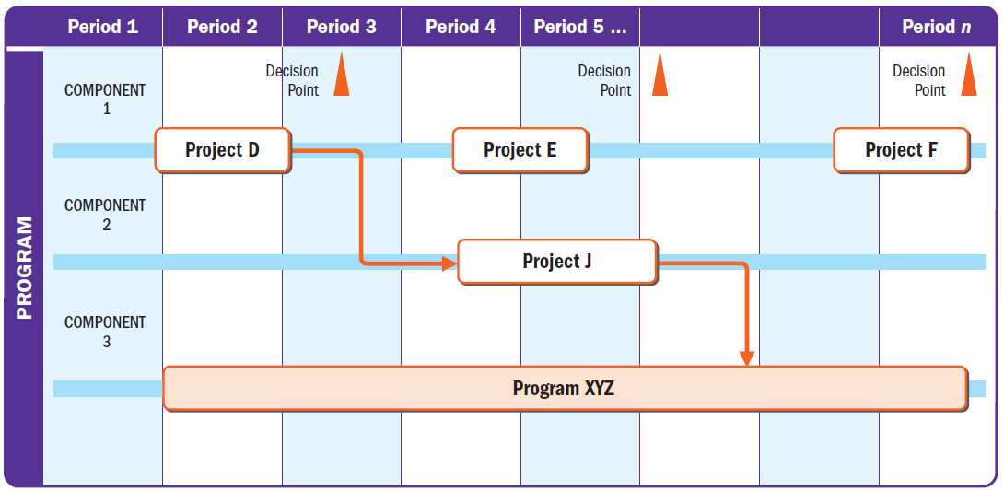

Key milestones
Significant points or events for making decisions and delivering benefits.

List of components
Subsidiary programs, projects, and program-related activities.

Component information
Component name, planned period (start and end), and targeted outcomes/benefits.

Dependencies
Connections across program components and benefits to create synergy.

Benefits realization period
How benefits are fully realized over time.

Benefits transition and sustainment period
When benefits make the transition from the programmatic to the operational levels.

